USB charging protector
UCS-53A

Instruction manual

From
design, for you

- Brief Introduction
Thanks for purchasing USB charging protector. It’s small, easy to carry, safe, stable and reliable, simple operation and high accuracy detection. It can be used to protect your mobile phone or IPAD (all models) while charging, with doing a good job in long-time-charging limited protection, over-current protection, over-voltage protection, under-voltage protection. With electronic switching circuit, the protector can identify the status of the device charging, intelligently control the electronic switch and can close charging while the power is full. So to mostly protect your electronic products. No matter when and where, it will take care of your favorite machine, prolong its life.
This instruction is about how to use this product and safety matters. Please firstly read before use. And keep this manual for future reference.
（Note: continuous optimization of product upgrade and instruction of the place without prior notice, hope understanding.）

- Product access
This product is used between the charging power and charging devices. The connection is shown as follow:
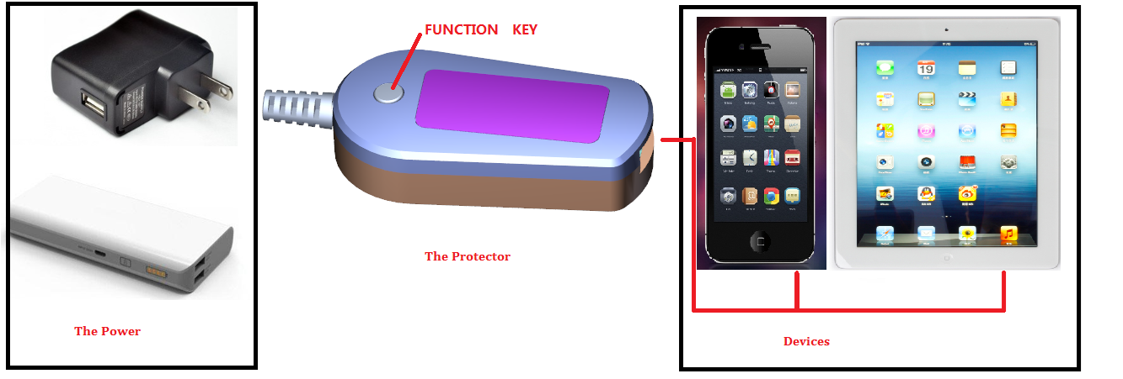

- Function introduction
- Real time displaying the voltage or current while charging.
- Charging protection: If the mobile phone or iPad device is fully charged, or charging time is too long(>8h), or a fault is occurred in the process, the product would automatically disconnected the connection of the mobile and charger, so to avoid causing security risks for overcharging, effectively extend the battery life!
- Automatic energy-saving: If the mobile device is offline or the charging task is complete, the product will shut off the output and turn off the display function. And then enter a power saving standby mode.
- Automatic identification on-line or off-line of the mobile: automatic judging whether the mobile phone is online. When equipment is on line, automatic charging. When the equipment is not online, automatically disconnect switch circuit, and enter the standby mode.
- Night mode: when charging at night, or do not need to display, the display can be closed by pressing the function key. Press 1 times, display voltage; press 2 times, enter the night mode. While in night mode, the display will be closed and the second decimal will flash every two seconds.
- Fully charging current threshold setting: in order to adapt all charging equipment, this product can set the threshold current which will be as the judgment for device fully charging.

- Technical parameters
Model: UCS-53A
Input voltage: 3.5V~6V
Current range: 0~3A

- Display definition

First Second Third

The display mode is defined as follows:
Mode 1: standby mode. The last decimal point is bright while the others is black.
Mode 2: display voltage: _5.0 (charging voltage is 5V, the first digital tube is not shown and the second decimal point is bright.)
Mode 3: display current: such as 0.80 (the charging current is 0.8A, the first decimal point is bright).
Mode 4: charging is complete or charging time is full: Show 0.00
Mode 5: when a charging fault is happen, the information will be display as ‘E.**’.
With three kinds of faults, defined as:
E.LV: charging voltage is under voltage
E.OV: charging voltage is over voltage
E.OA: charging current is overflow
Pressing the function key can clear the current error information, or you can power off the system and check the connection and repower. If the current failure is still exist, the fault code will be redisplayed. If the voltage is fault, the system will automatically clear the fault according to the voltage recovery case.
Mode 6: Night mode. The second decimal point will flash per 2S, the other’s display will not show.
Mode 7: Current setting mode. The second and third digital tubes will display for unit 10mA. When the display is 12, saying 120mA, while 1 saying 10mA. Current setting range is 10mA~150Ma, default 60mA.

- System function
When some fault is happen, the system will cut off the charging circuit and then display the mode 5 fault code.
No fault conditions:
- When the charging device is offline, the system will disconnect the charging circuit and in 1 minutes display mode 2 the voltage value. After the first minute, the system will display standby mode.
- When the charging device is online, the system will connect the charging circuit and display mode 3 charging current value. In this mode, press the function key to display mode 2 voltage value, and in 5 seconds without repress the key, the system will automatically return mode 3 displaying the current value. In mode 2 displaying voltage value, in 5 seconds repressing the function key will enter the night mode. In night mode, repressing the function key will return back to display the charging current. Pressing function key will switch between current mode, voltage mode and night mode. (Warm tip: the charging task will keep at least 1 minutes. If the charging device is disconnected within 1 minutes, the current will display as 0. After the first minute, the system will check the device charging status and on-off-line status.)
- If the mobile is fully charged or the charging time is full (up to 8 hours), the system will automatically disconnect the charging circuit and enter the standby mode.
- The changing of the device’s online and offline will make the system exit the standby mode at any time.(Warm tip: For the Apple device, the system may take an error for its online or offline status, but, please press the function key to recheck the device for charge. Apple device charging line online will be recognized as the Apple device’s online.)
- The current setting mode: without fault, pressing down the function key for 5 seconds, the system will directly enter the mode 7 current setting mode. In this mode, once press of function key will modify the setting value. The current setting value will be a judgement for fully charging device. Without any press operation in 5 seconds, the system will exit the current setting mode. Current setting range is 10mA~150mA, default 60mA.
(Warm tip: For different charging solutions of mobiles, the charging current value is also different. The value should be suitable. If it’s too large, your mobile may not be charged fully. If it’s too small, your mobile may be always in charging. If you do not want cutting off circuit function, you can set the value very small, for example 10mA. You can set wanted value. )

- Common problems and matters needing attention

Failure phenomenon | Main reasons | Solutions
No display | No power supply | Check the USB power supply side and whether the connection is ok.
The system didn’t enter the standby mode while the device is offline. | Apple device charging line. The existence of Apple devices charging line will be taken as Apple devices’ online. | Press function key to recheck.  Recommend that the Apple device charging line access or disconnect from the product side access or disconnect.
Charging current always display 0 | After accessing the mobile phone or IPAD, 1 minute later unplug. | When the product accessing the device, at least charging 1 minute. In the first 1 minute, any access devices can start charging. 1 minute later, start to judge device charging status or others.
Charging in night, but display less than 100% in the morning. | If you are on the boot to charge, the device will automatically disconnect the charging. Due to the turned on status of the device, from the time of disconnecting switch circuit to the morning time, the mobile has power consumption. | The number of the device charging determines the service life of the battery. Therefore, when the device is charging full, the product is not used to recharge the battery to prolong the service life of the battery. Or, the user can set the current threshold value to be a little small in mode 7 to extend the charging time.
Doesn’t turn-off the charging circuit while the mobile is full. | Current setting value is too small | In mode 7, set the current value bigger. It is recommended that this value is set to be little 20mA than display value while charging full.
Turn off the charging circuit while the mobile is no full. | Current setting value is too large | In mode 7, set the current value smaller. It is recommended that this value is set to be little 20mA than display value while charging full.

USB charging protector UCS-53A
Warranty Card
Dear user:
Thank you for purchasing our company’s USB charging protector. All products of our company can enjoy 15 days replacement, 6 months warranty after-sales service policy. In order to ensure your legitimate rights and interests, please carefully read the warranty card and safekeeping.
Use instructions:
This is the only certificate of warranty card as our company’s product warranty.
In 15 days from the day of sale, if there is something wrong, but the product itself and the packaging is intact, no scratches, we can replace the same type of products(except for man-made factors).
In 6 months from the day of sale, if there is something wrong, you can enjoy paid service warranty (except artificial factors).
Excess the product warranty period, it is not within the scope of the warranty.
The accessories are not within the scope of the warranty.
Unable to provide the warranty card, it is not within the scope of the warranty.
Certification
Date of manufacture:

Inspector:

Warranty record
Model |  | Date of purchase
Warranties |  | Warranty Date

