U-easytech STM32-144C-47Z/UET

STM32-144C-47Z/UET CORE BOARD

Description:
The STM32-144C-47Z/UET core board is based on the ST chip STM32F407ZGT6. All the GPIOS are lead out by 2.54mm pitch. The led flashing program is provided.
With the JTAG interface you can use debugger STLINKIII or JLINKV8 test your program.

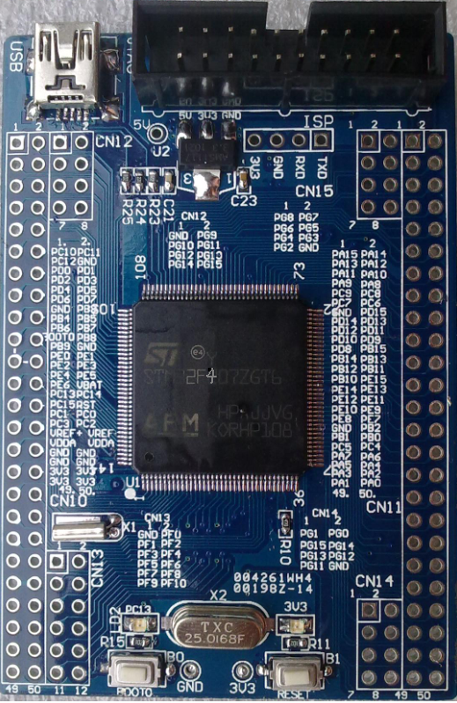
Features:
- MCU: STM32F407ZGT6 (144pin)
- Core work at up to 168M frequency
- 1MB Flash and 192+4KB RAM
- 25M crystals
- TXD, RXD, GND Pads
- 1 Reset Key
- 1 Boot Jumper
- 1 Power Led
- 1 User Led
- 1 USB power interface
- JTAG Debug port
- 3.3V Regulator IC

Order NO: STM32-144C-47Z/UET
STM32F407ZGT6
3.3 regulator ic

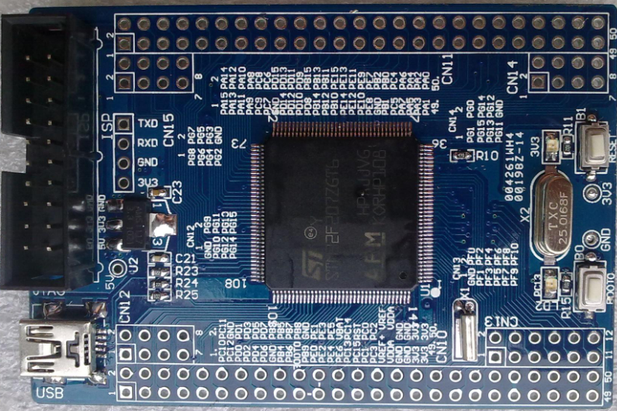
JTAG Port
Power Led

Reset Key

USB Power
Reset Key

User Led
2.54mm

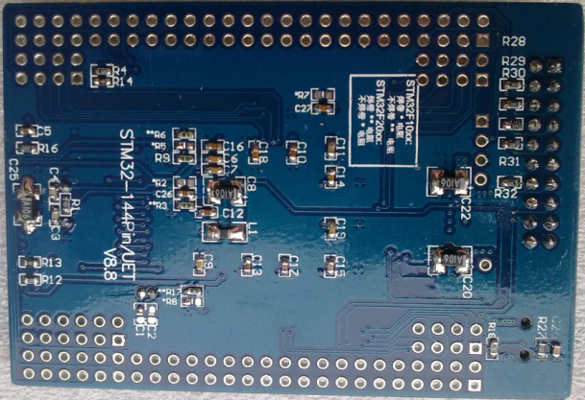

Back View

SIZE:

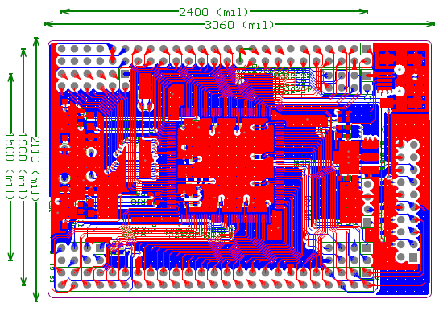

Note:
1CM=393.7 mil
Length*Width: 7.6CM*5.2cm

U-easytech STM32-144C-47Z/UET

STM32-144C-47Z/UET 核心板

简介:
STM32-144C-47Z/UET核心板使用ST芯片STM32F407ZGT6。所有GPIO都能过2.54mm标准间距通过双排针引出。核心板出厂配有指示灯闪烁用户程序。
用户可以用STLINK仿真噐或JLINK仿真器通过JTAG口仿真下载程序。

特点:
- MCU: STM32F407ZGT6 (144脚)
- 最大工作频率：168M
- 1MB Flash and 192+4KB RAM
- 25M 晶振
- TXD, RXD, GND焊盘
- 一个复位键
- 一个Boot跳线
- 一个电源指示灯
- 一个用户指示灯
- 一个USB电源接口
- JTAG调试口
- 3.3V稳压电路

订单编号: STM32-144C-47Z/UET

