U-easytech STM32-48C-13C/UET

STM32-48C-13C/UET CORE BOARD

Description:
The STM32-48C-13C/UET core board is based on the ST chip STM32F103C8T6. All the GPIOS are lead out by 2.54mm pitch. The led flashing program is provided.
With the JTAG interface you can use debugger STLINKIII or JLINKV8 test your program.

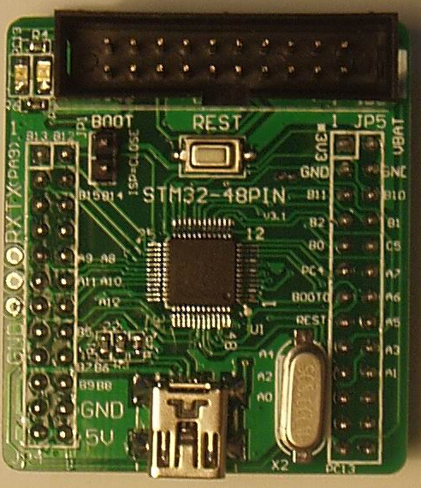
Features:
- MCU: STM32F103C8T6 (48pin)
- Core work at up to 72M frequency
- 64KB Flash and 20KB RAM
- 8M crystals
- TXD, RXD, GND Pads
- 1 Reset Key
- 1 Boot Jumper
- 1 Power Led
- 1 User Led
- 1 USB power interface
- JTAG Debug port
- 3.3V Regulator IC

Order NO: STM32-48C-13C/UET
JTAG Port
USB Supply
STM32F
103C8T6
Reset Key
8M Crystal
User Led
Power Led
2.54mm
Boot Jumper

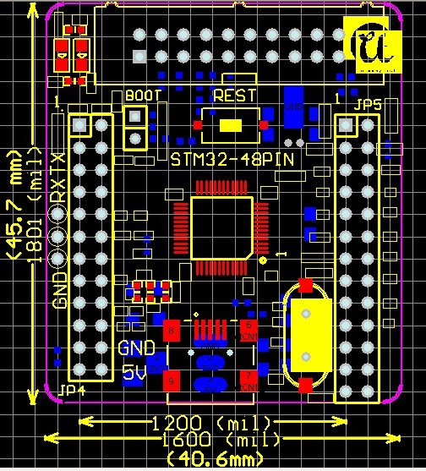

U-easytech STM32-48C-13C/UET

STM32-48C-13C/UET 核心板

简介:
STM32-48C-13C/UET核心板使用ST芯片STM32F103C8T6。所有GPIO都能过2.54mm标准间距通过双排针引出。核心板出厂配有指示灯闪烁用户程序。
用户可以用STLINK仿真噐或JLINK仿真器通过JTAG口仿真下载程序。

特点:
- MCU: STM32F103C8T6 (48脚)
- 最大工作频率：72M
- 64KB Flash and 20KB RAM
- 8M 晶振
- TXD, RXD, GND焊盘
- 一个复位键
- 一个Boot跳线
- 一个电源指示灯
- 一个用户指示灯
- 一个USB电源接口
- JTAG调试口
- 3.3V稳压电路

订单编号: STM32-48C-13C/UET

