U-easytech STM32-64C-03R/UET

STM32-64C-03R/UET CORE BOARD

Description:
The STM32-64C-03R/UET core board is based on the ST chip STM32F030R8T6. All the GPIOS are lead out by 2.54mm pitch. The led flashing program is provided.
With the SWD interface you can use debugger STLINKIII or JLINKV8 test your program.

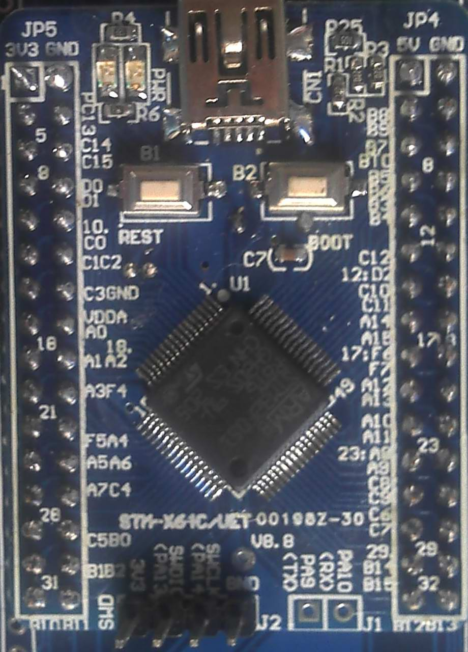
Features:
- MCU: STM32F030R8T6 (64pin)
- Core work at up to 48M frequency
- 64KB Flash and 8KB RAM
- 8M crystals
- TXD, RXD Pads
- 1 Reset Key
- 1 Boot Key
- 1 Power Led
- 1 User Led
- 1 USB power interface
- SWD Debug port
- 3.3V Regulator IC

Order NO: STM32-64C-03R/UET
SWD port
STM32F
030R8T6
Boot Button
USB Supply
2.54mm
Reset Button

Power and user Leds

TXD RXD

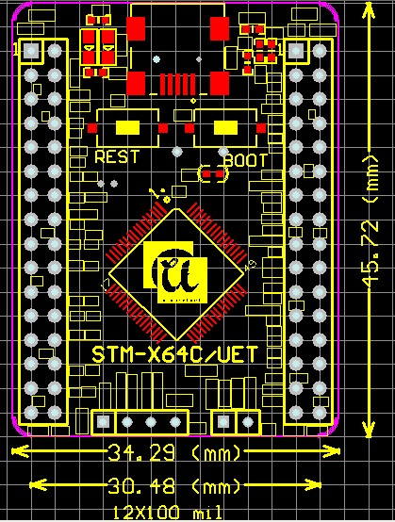

U-easytech STM32-64C-03R/UET

STM32-64C-03R/UET 核心板

简介:
STM32-64C-03R/UET核心板使用ST芯片STM32F030R8T6。所有GPIO都能过2.54mm标准间距通过双排针引出。核心板出厂配有指示灯闪烁用户程序。
用户可以用STLINK仿真噐或JLINK仿真器通过SWD口仿真下载程序。

特点:
- MCU: STM32F030R8T6 (64脚)
- 最大工作频率：48M
- 64KB Flash and 8KB RAM
- 8M 晶振
- TXD, RXD焊盘
- 一个复位键
- 一个Boot键
- 一个电源指示灯
- 一个用户指示灯
- 一个USB电源接口
- SWD调试口
- 3.3V稳压电路

订单编号: STM32-64C-03R/UET

