U-easytech STM32-X64-MC-13R/UET

STM32-X64-MC-13R/UET BOARD

Description:
The STM32-X64-MC-13R/UET board has been designed as a complete demonstration and development platform for the ARM cortex-M3 core-based STM32F103RBT6 microcontroller. It features two I2Cs, two SPIs, three USARTs, two 12-bit 16 channels ADCs, internal 20-KByte Data SRAM and 128-KByte Flash, JTAG SWD mode debugging support. This evaluation board can be used as the reference design for user application development but it is not considered as a final application. With the SWD interface you can use debugger STLINKIII or JLINKV8 to test your program.

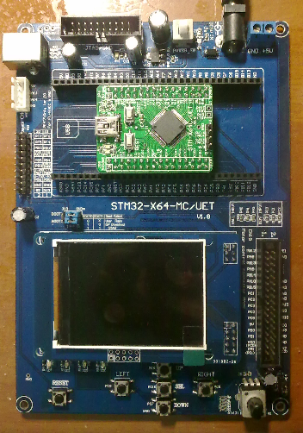
Features:
- MCU: STM32F103RBT6 (64pin)
- Core work at up to 72M frequency
- 128KB Flash and 20KB RAM
- l 2.4’ TFT LCD
- 4 User Leds, 5 User Keys
- 1 Power Key, 1 Reset Key
- 1 Power Led
- 1 DV 5V power interface
- 1 I2C EEPROM 24C02
- 1 SPI SD card interface
- 1 AD channel with Pointer
- l RTC with backup battery interface
- With motor control connector
- l JTAG Debug port
- l ALL I/O expansion

Order NO: STM32-X64-MC-13R /UET
System description：
JTAG PORT
Rower Key
Power Led

DV 5V
USB Power

SWD port

All IO pin

STM32F103RBT6
Core board
Boot choose

SPI SD card

I2C eeprom

Motor control port
2.4 LCD

4 User Ledss

AD Pointer
Reset Key
5 user keys

U-easytech STM32-X64-MC-13R/UET

STM32-X64-MC-13R/UET 开发板

简介:
STM32-X64-MC-13R/UET开发板是一块基于CORTEX-M3内核的STM32F103RBT6微处理器的开发平台。STM32F103RBT6有2个I2C,2个SPI,3个USART, 2个12位16通道ADC转换器，内部有20KB的Data SRAM，128KB的FLASH,支持JTAG SWD模式调试。此评估平台可作为用户应用开发时做参考，而未作最终产品应用考虑。用户可通过SWD用STLINK或JLINK仿真下载程序。

特点:
- CPU:STM32F103RBT6 (64pin)
- 最大工作频率：72M
- 128K FLASH,20K RAM
- 一个2.4 TFT 液晶
- 4个用户指示灯，5个用户按键
- 1个电源开关，一个复位键
- 一个电源指示灯
- 一个DV5V输入接口
- 一个24C02 存储芯片
- 一个AD电位器
- 电池接口
- 电机控制接口
- 一个SPI SD卡接口
- 一个SWD下载口
- 所有IO引出

订单编号: STM32-X64-MC-13R /UET

