U-easytech STM3240Z-CRE/UET

STM3240Z-CRE/UET BOARD

Description:
The STM3240Z-CRE/UET board has been designed as a complete demonstration and development platform for the ARM cortex-M4 core-based STM32F407ZVGT6 microcontroller. It features three I2Cs, three SPIs, six USARTs, two CANs, three 12-bit ADCs, two 12-bit DACs, internal 192-KByte Data SRAM and 1MByte Flash, USB FS, JTAG debugging support. This evaluation board can be used as the reference design for user application development but it is not considered as a final application. With the JTAG interface you can use debugger STLINKIII or JLINKV8 to test your program.

Features:
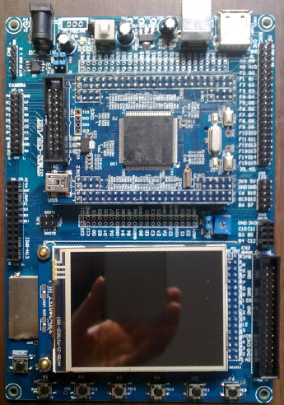
- MCU: STM32F407ZGT6 (144pin)
- Core work at up to 168M frequency
- 1MB Flash and 192KB RAM
- USB Device、SDIO interface
- l 2.8’ TFT LCD
- 1 CAN channel port
- 4 User Leds, 6 User Keys
- 1 Power Key, 1 Reset Key
- 1 Power Led
- 1 DV 5V power interface
- 1 I2C EEPROM 24C02
- 1 SPI FLASH AT45DB161
- 1 AD channel with Pointer
- l RTC with backup battery interface
- 1 camera OV9655 module
- USB OTG FS interface
- l JTAG Debug port
- l ALL I/O expansion
Order NO: STM3240Z-CRE/UET
System description：

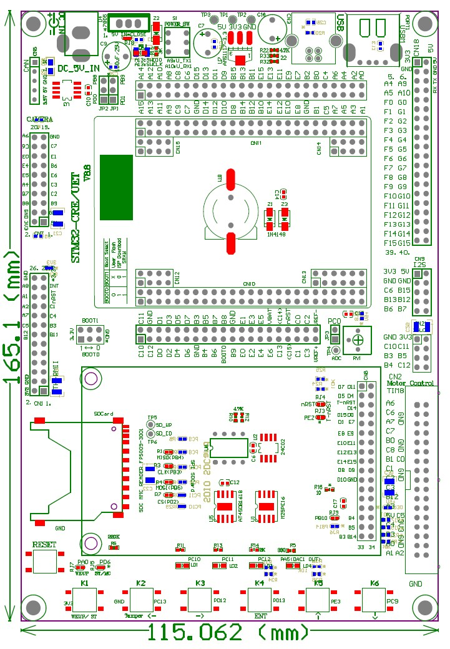
4 User Ledss
Reset Key
6 User Keys
TFT LCD
& touch
SPI or SDIO interface
SPI Flash
AT45DB/M25P
I2S interface
Boot SW Jump
DC 5V IN
Camera for F2/F4 CPU
Ethernet for F2/F4 CPU
ADC Pointer
CAN chip
CAN interface
24L01 CN
DIP/SOP
MC control
interface

nRF24L01
interface
Part GPIOs
Back-up
Battery
STM32F407ZGT6
CORE BOARD

Power Led
JTAG CN
Two kinds
Interface
Of USB

Power Key

U-easytech STM3240Z-CRE/UET

STM3240Z-CRE/UET 开发板

简介:
STM3240Z-CRE/UET开发板是一块基于CORTEX-M4内核的STM32F407ZGT6微处理器的开发平台。STM32F407ZGT6 有3个I2C,3个SPI,6个USART,2路CAN,3个12位ADC转换器，2个12位DAC转换器，内部有192KB的Data SRAM，1MB的FLASH,支持USB FS和JTAG调试。此评估平台可作为用户应用开发时做参考，而未作最终产品应用考虑。用户可通过JTAG用STLINK或JLINK仿真下载程序。

特点:
- CPU:STM32F407ZGT6 (144pin)
- 最大工作频率：168M
- 1MB FLASH,192K RAM
- 具有USB 从设备接口和SDIO接口
- 一个2.8 TFT 液晶
- 一路CAN通道接口
- 4个用户指示灯，6个用户按键
- 1个电源开关，一个复位键
- 一个电源指示灯
- 一个DV5V输入接口
- 一个24C02 存储芯片
- 一个SPI FLASH AT45DB161
- 一个AD电位器
- 电池接口
- 摄像头模块接口
- 以太网模块接口
- 一个JTAG口
- 所有IO引出
订单编号: STM3240Z-CRE/UET

