U-easytech STM8-QC/UET

STM8-QC/UET BOARD

Description:
The STM8-QC/UET board has been designed as a complete demonstration and development platform for STM8 STM8S207RBT6 microcontroller. STM8S207RBT6 features ont I2C, one SPI, two UARTs, one 10-bit 16 channels ADC, 2KB EEPROM, internal 6-KByte Data SRAM and 128-KByte Flash, SWIM mode debugging support. This evaluation board can be used as the reference design for user application development but it is not considered as a final application. With the SWIM interface you can use debugger STLINKIII or STLINK V2 to test your program.

Features:

- MCU: STM8S207RBT6 (64pin)
- Core work at up to 24M frequency
- 128KB Flash and 6KB RAM
- l 128*64 OLED
- 6 User Leds, 4 User Keys
- 1 Reset Key,1 Power Led
- 1 MN-USB POWER interface
- 1 AD channel with Pointer
- With motor control connector
- l SWIM Debug port
- l ALL I/O expansion

Order NO: STM8-QC /UET
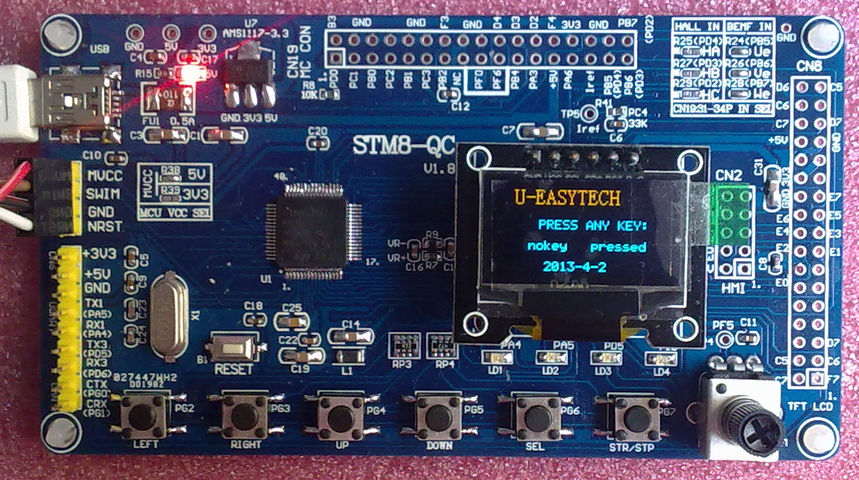

System description：

Reset KEY
STM8S207RBT6
3.3V IC
AD Pointer
4 LEDS
24M
SWIM
Motor control port
6 KEYS
USB Power
Power Led
UART PINS
12864 OLED

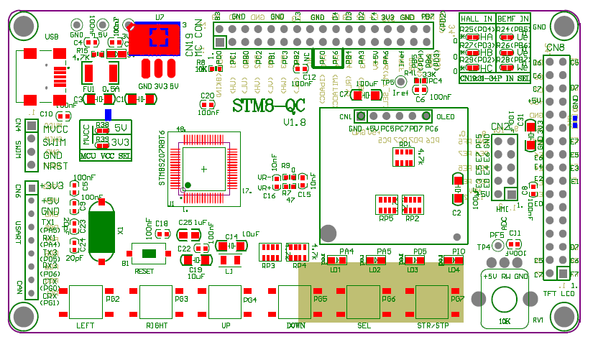

U-easytech STM8-QC/UET

STM8-QC/UET 开发板

简介:
STM8-QC/UET开发板是一块基于STM8S207RBT6(64pin)微处理器的开发平台。STM8207RBT6有1个I2C,1个SPI,2个USART, 1个10位16通道ADC转换器，内部有2KB的EEPROM，6KB的Data SRAM，128KB的FLASH,支持SWIM模式调试。此评估平台可作为用户应用开发时做参考，而未作最终产品应用考虑。用户可通过SWIM用STLINKIII或STLINK V2仿真下载程序。

特点:

- CPU:STM8207RBT6 (64pin)
- 最大工作频率：24 M
- 128K FLASH,6K RAM
- 2KB EEPROM
- 一个12864 OLED液晶
- 4个用户指示灯，6个用户按键
- 一个复位键、一个电源指示灯
- 一个MN-USB电源输入接口
- 一个AD电位器
- 电机控制接口
- 一个SWIM下载口
- 所有IO引出

订单编号: STM8-QC /UET

